**Wheelchair Accessible Businesses in London**

Sorry that I still need more time on changing content and reference. You can combine this with others first and I can replace this later in the final one. Thank you so much

1. **Motivations**

This section focuses on wheelchair accessible businesses, which can reflect the living convenience for disabled people who travelling around by wheelchair. For nearly 1 in 5 people are disabled in the UK, wheelchair accessibility is not only important for disabled people, but also beneficial for the owner of a business so that the target market can be enlarged a lot (Euan's Guide, 2019). To visualize and analyze the current situation about wheelchair accessible business, data from Yelp – a famous review forum is being used. London, which has the most businesses in the UK as the capital, has been chosen as the case. The points listed below are the main objectives for this part. (I don’t know whether this part will repeat the introduction part. If yes, I will change later)

(1). Draw a map of the current wheelchair accessible businesses in London so that the distribution can be seen straightforwardly;

(2). Create a search function that people can find their positions and read detailed information about businesses around easily;

(3). Investigate the distribution of wheelchair accessible businesses in each borough of London to analyse the spatial unfairness;

(4). Calculate the percentage that wheelchair accessible businesses take up in all businesses in London to show the emphasis degree of business wheelchair accessibility.

1. **Methods**

HTML is utilized to do the visualization based on Yelp API, Mapbox GL JS and CanvasJS.

**2.1. Data acquisition and processing**

Python is used to retrieve Yelp business search (2019) response by adjusting Sigma Coding’s (2018) tutorial code. By setting ‘limit’ and ‘offset’ values learnt from london-rhythms’ (2018) Github code, this endpoint can return up to 1000 businesses. For the quantity for any category of wheelchair accessible business is less than 1000, complete

1. Python: achieve data from yelp API and clean it and transfer it into csv
2. Excel: Merging some categories: <https://www.yelp.com/developers/documentation/v3/all_category_list> (travel = eventservices + hotelstravel, leisure = active + arts + education, beauty and health = beautysvc + health, local services = homeservices + localservices + pets + professional + publicservicesgovt)
3. ArcGIS: join points with borough boundary shapefile and export the shapefile
4. Mapbox: upload csv and shapefile as tilesets

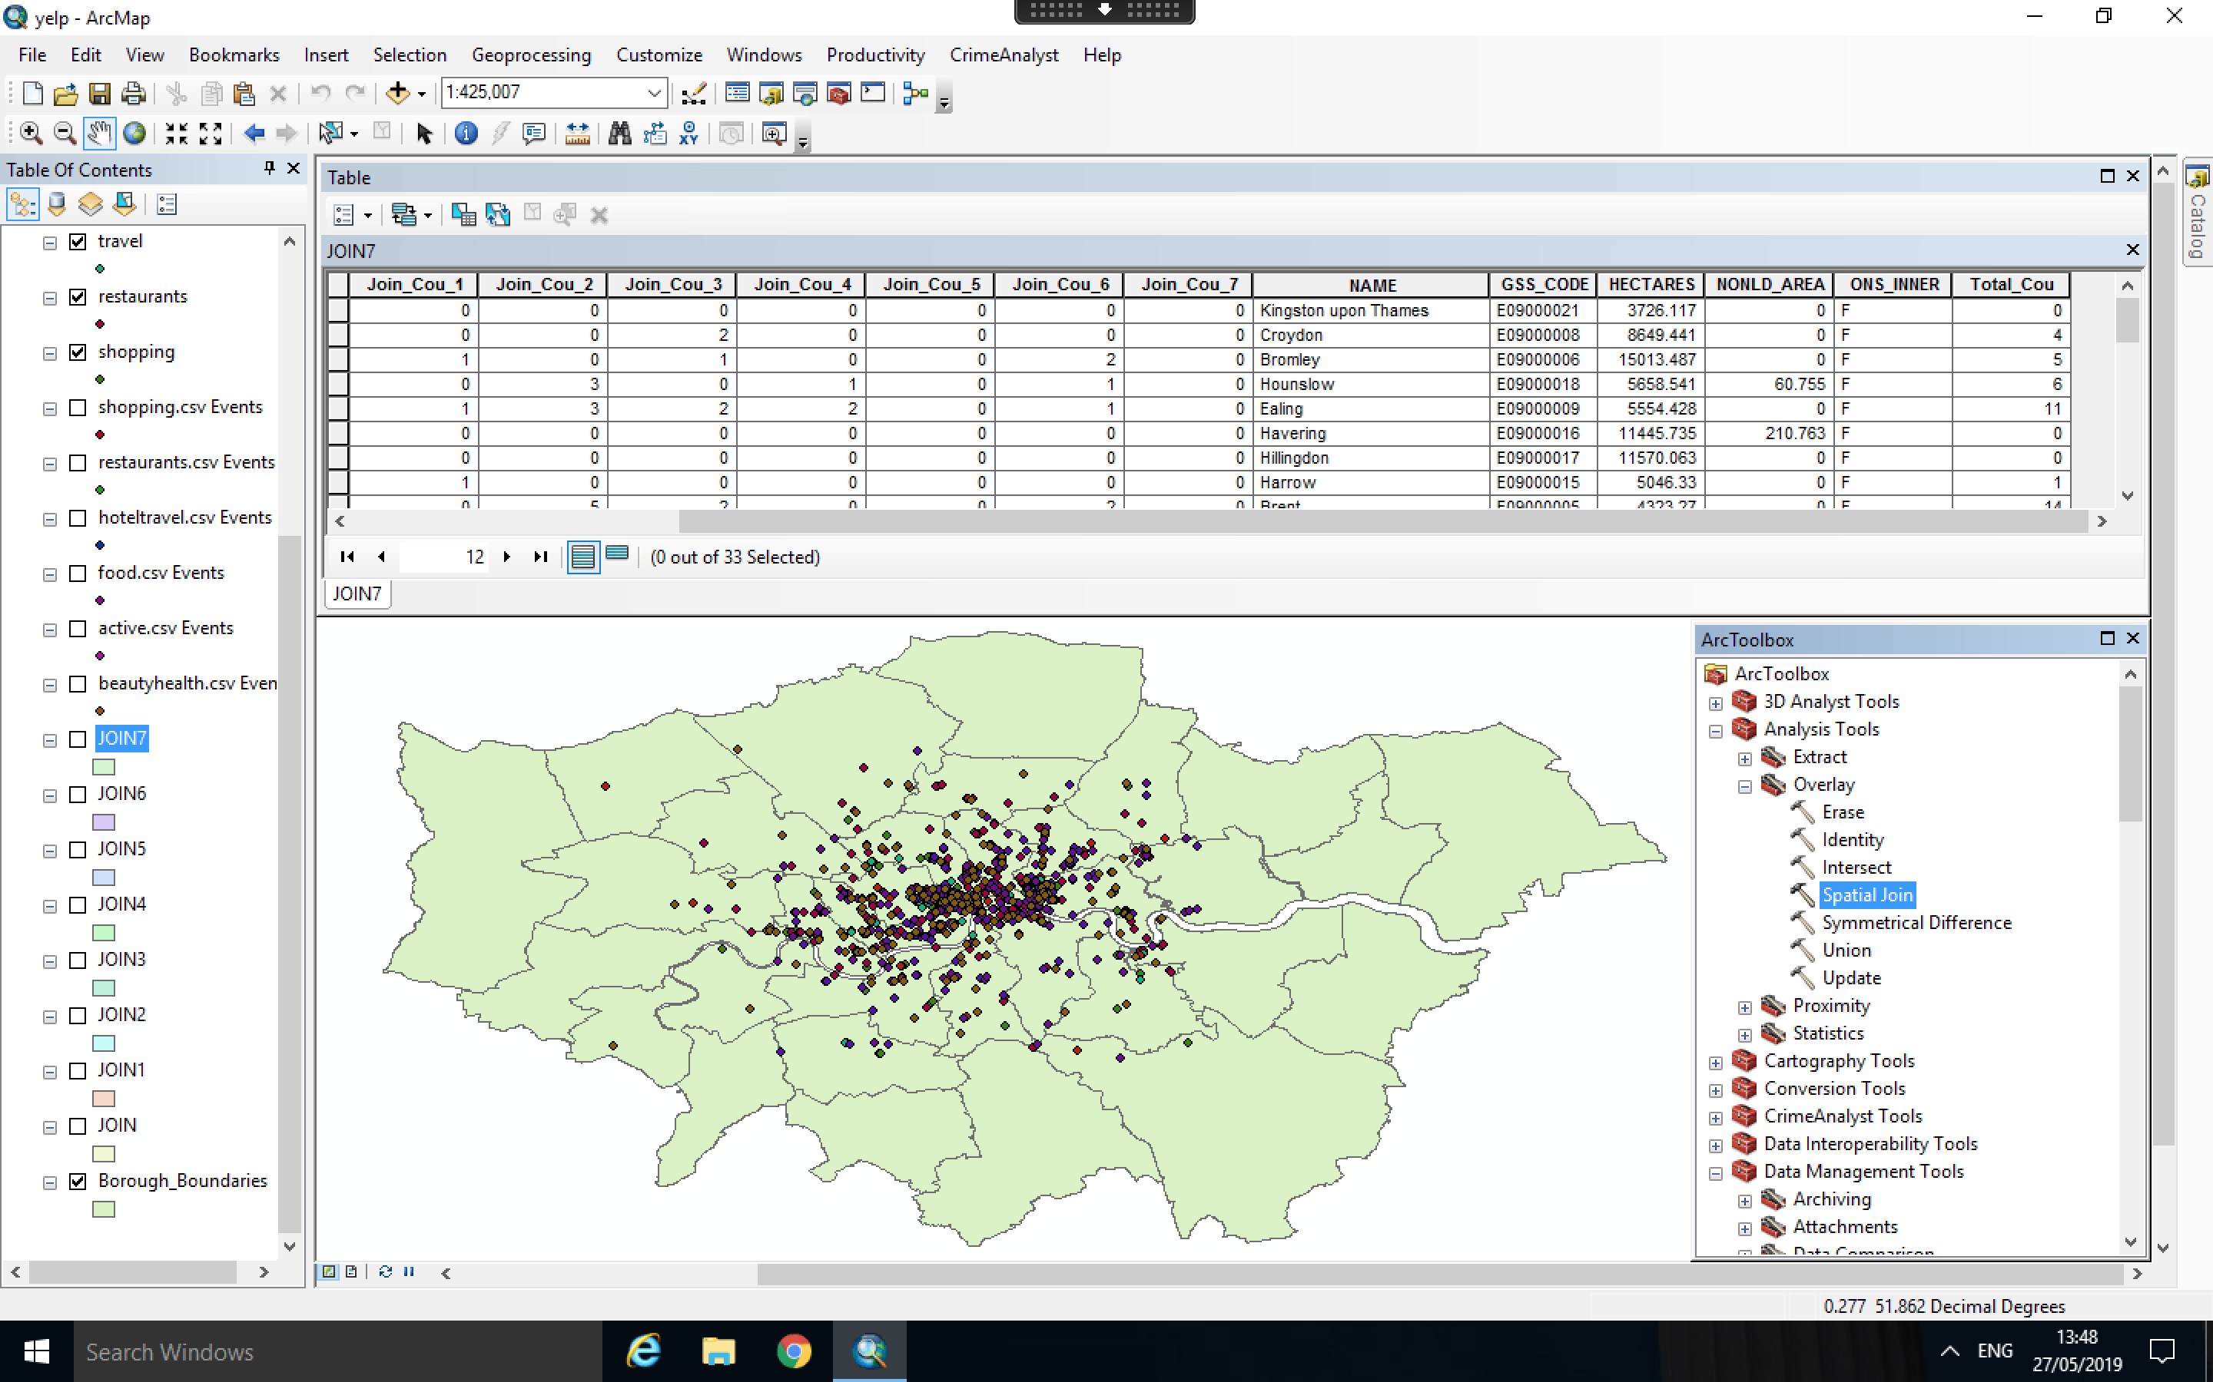

Figure 1. Join Business Points with London Borough Boundary Polygons in ArcMap

* 1. **Interactive Website Construction**

1. Mapbox GL JS: add layers and buttons
2. Mapbox GL JS: add search function
3. Mapbox GL JS: add popup
4. CanvasJS: add charts
5. **Results**

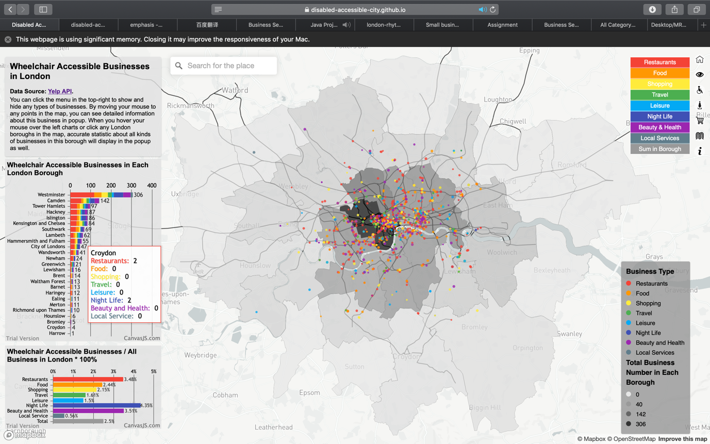

Figure 2. Final Visualization

From the map and the chart in the left, obviously, most wheelchair accessible businesses are located in the inner London. Especially in Westminster, the quantity of every type of business is several times than any other boroughs. It indicates that it’s unfair for disabled people who live in outer London for they have to travel a long time to arrive in the businesses which are marked as ‘wheelchair accessible’ in Yelp.

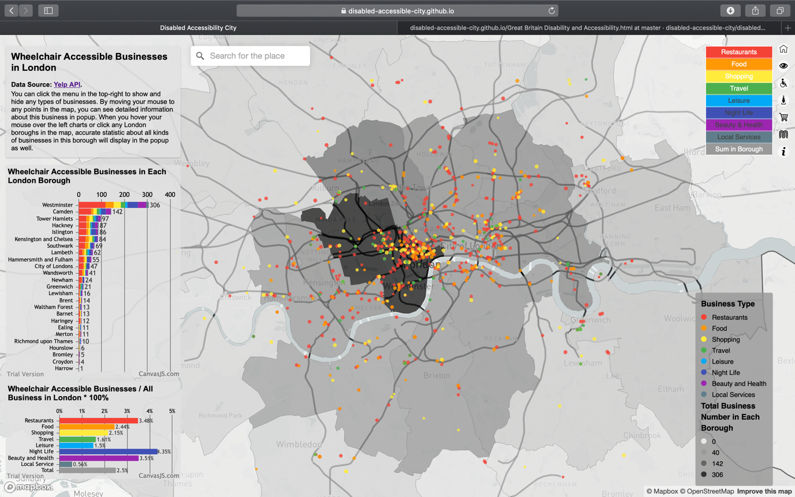

Figure 3. Distribution of Restaurant, Food, Shopping and Travel Businesses

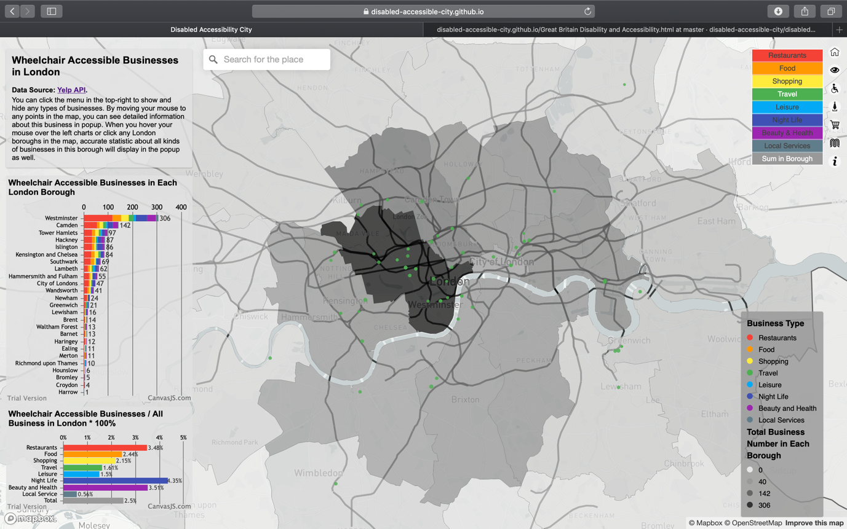

Figure 4. Distribution of Travel Businesses

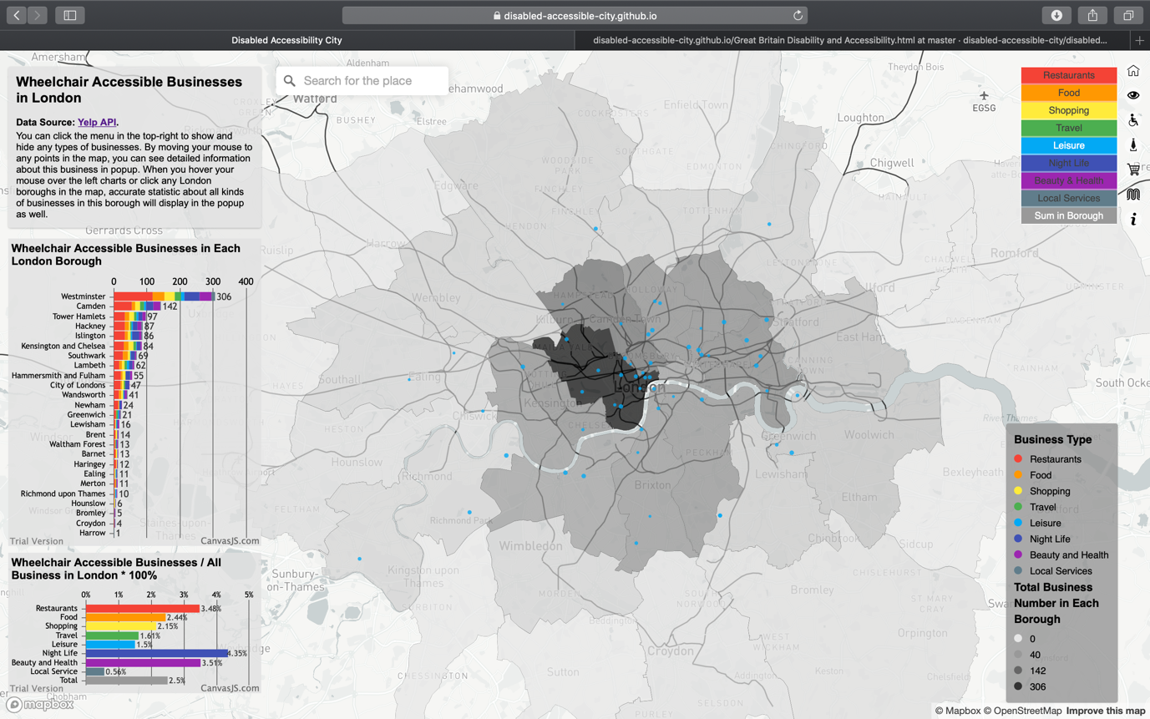

Figure 5. Distribution of Leisure Businesses

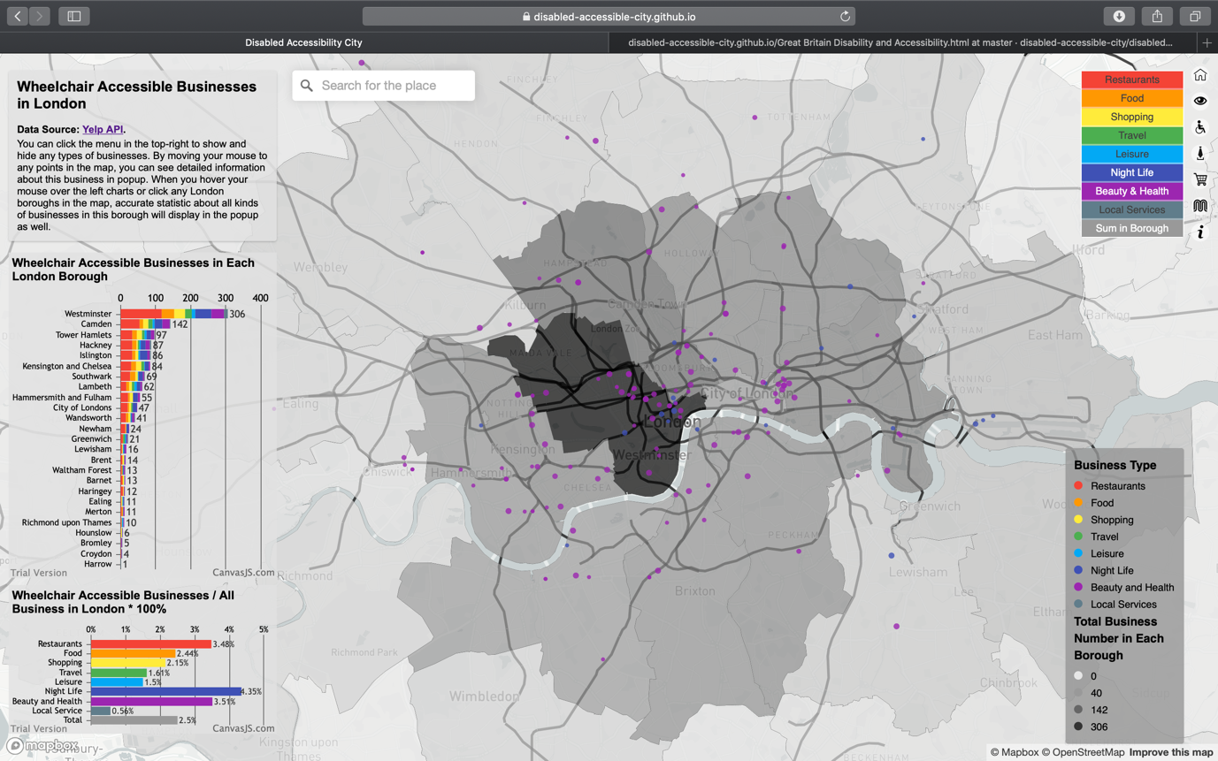

Figure 6. Distribution of Night Life and Health & Beauty Businesses

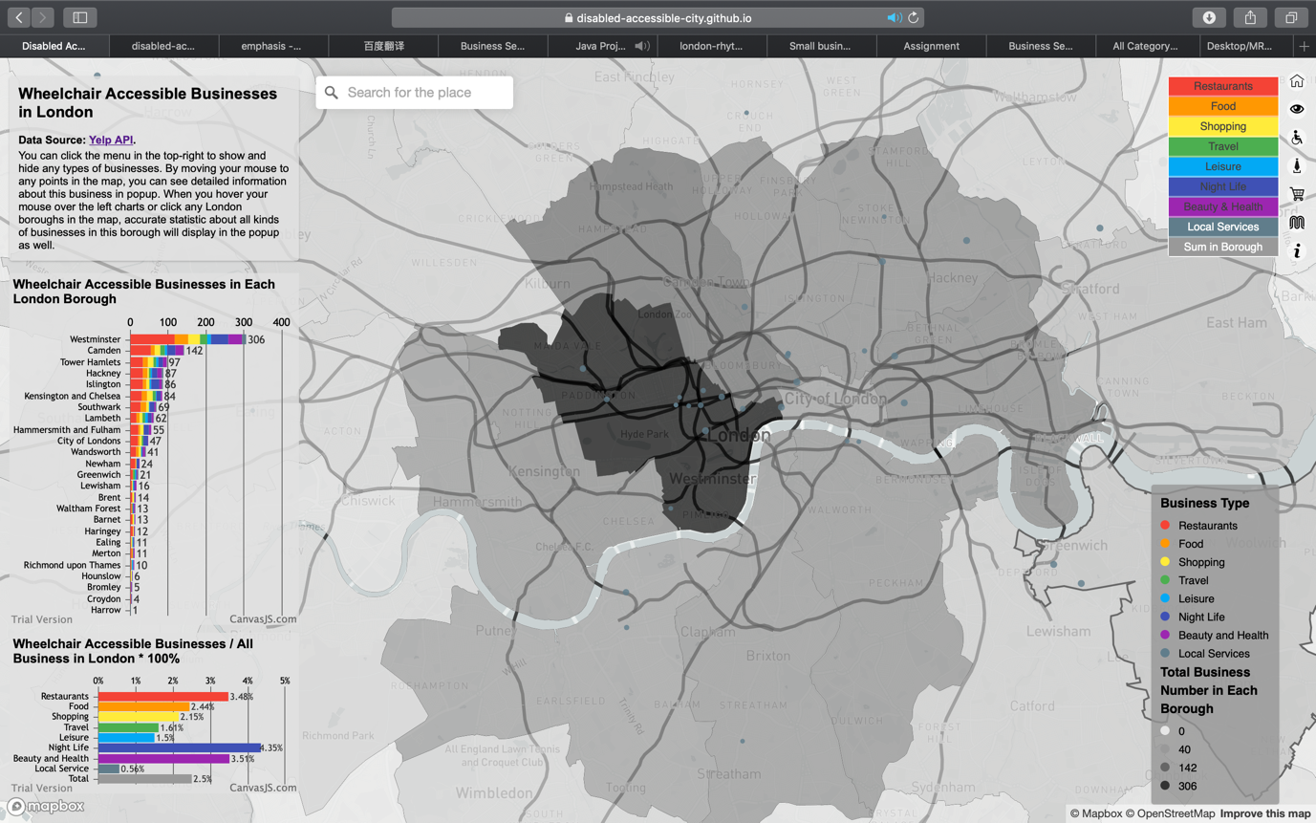

Figure 7. Distribution of Local Service Businesses

By clicking the buttons in the top-right, we can show or hide the layer of every category of business. As we close all layers at first and display them one by one, we can see that restaurants are clustering in the West End and the East End of London. After open food layer, which includes cafes, groceries and so on, we can find that the location of them is very similar to restaurants. For shopping stores, such as shopping centres and bookstores, again, they love to be the neighbours with restaurants. However, for hotels and other travel-related facilities, they are more likely to distribute in the boundary of high-density area of restaurants and shops. It makes sense because they want to be convenient to access restaurants and shops while they wish the environment is not so noisy. Also, almost every wheelchair accessible hotel is very close to tube lines so that more transportation convenience can be created for disabled people. For leisure facilities, such as museums, theatres, gyms, they seem scatter more randomly in London. For night life facilities, such as pubs and bars, and beauty and health stores, such as barbers, skin care and massage, if we can remember the distribution of restaurants, they are quite similar. For local services, such as computer, phone, bike repair stores, they gather in oxford street and locate randomly in other area. Based on the regulations we find above, disabled people can seek out the place which fits their needs more quickly.

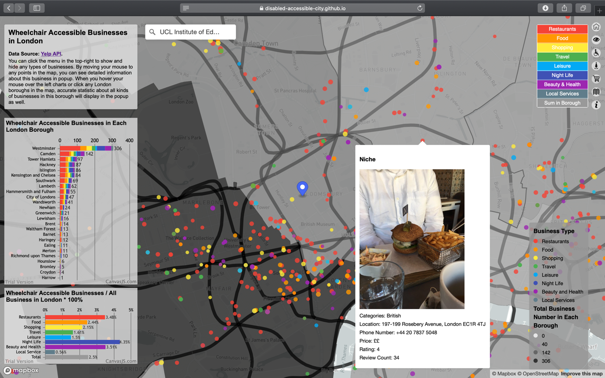

Figure 8. Search Function and Business Popup

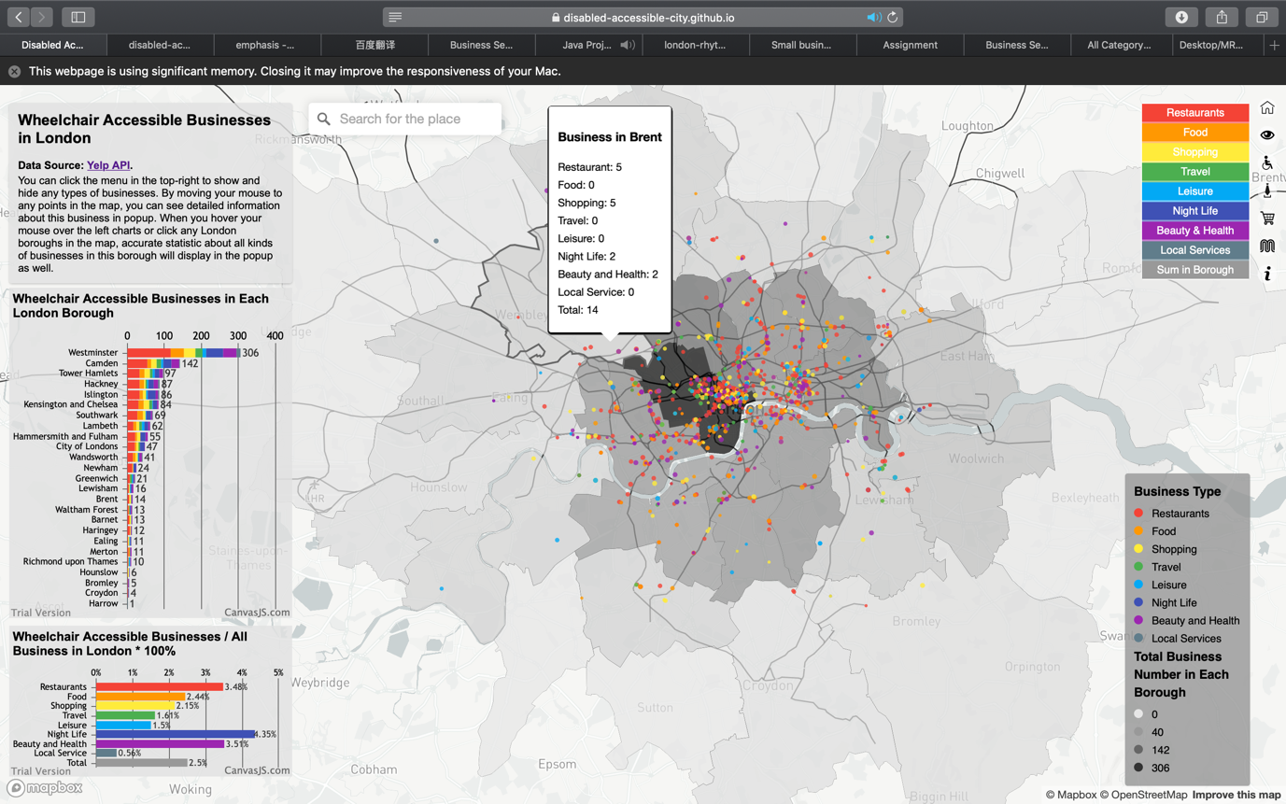

Figure 9. Borough Business Popup

There is a search bar in the middle top as well, people can search for their locations and the map will zoom in to this place. Take UCL as an example, we type UCL and search, then the map will zoom in to UCL, if we want to seek restaurants which is accessible for wheel-chair, we just move the mouse to the red points around to see the popup which displays the name, picture, category, price level and rating scores of every business, and I have set the point radius equal to rating score, higher the rating, bigger the points, so that we can find the most satisfied place rapidly. By clicking each borough in the map or the chart, we can see accurate numbers of businesses in this borough so that we can learn the current situation of living convenience for disabled people in each borough of London more deeply.

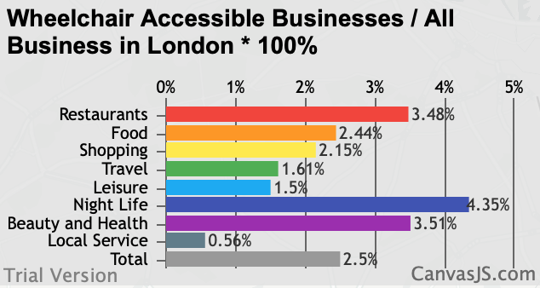

Figure 10. Histogram on Wheelchair Accessible Businesses / All Business in London * 100%

The chart about the percentage of wheelchair accessible businesses in total quantities of each type of business in the bottom-left demonstrates that businesses in London generally pay little attention in disabled people. All kinds of businesses take up less than 5%, particularly for local service, which only takes up 0.56%.

In conclusion, the current wheelchair accessible businesses situation in London is a little terrible.

**Bibliography**

Euan's Guide (2019) *Small Businesses and Accessibility.* [Online]. Available at: <https://www.disabledaccessday.com/news/small-businesses-accessibility/?tag=useful+articles>

london-rhythms (2018) *data processing.* [Online]. Available at: <https://github.com/london-rhythms/london-rhythms.github.io/tree/master/yelp/data%20processing>

Sigma Coding (2018) *Using the Yelp API in Python (1).* [Online]. Available at: <https://www.youtube.com/watch?v=GJf7ccRIK4U>